**PARLIAMENT OF THE PROVINCE OF THE WESTERN CAPE**

FRIDAY, 21 MAY 2021

QUESTION PAPER FOR WRITTEN REPLY

1. **Mr B N Herron to ask Mr A W Bredell, Minister of Local Government, Environmental Affairs and Development Planning:**

With regard to the Equitable Share Grant received from the National Treasury:

(a) What amount has been allocated to each municipality in the province, including the City of Cape Town, (b) how much does each municipality allocate to free basic services, (c) how many households receive free basic services per municipality and (d) what is the composition of each municipality’s free basic services and indigent relief?

**REPLY:**

1. **What amount has been allocated to each municipality in the province, including the City of Cape Town**



Source: Provincial Treasury

1. **How much does each municipality allocate to free basic services**



Source: Provincial Treasury

1. **how many households receive free basic services per Municipality**



Source: Provincial Treasury

1. 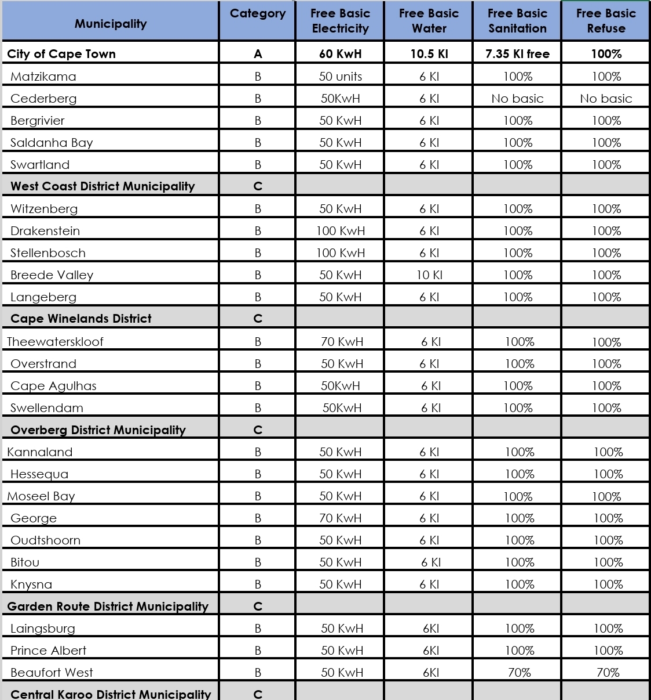**what is the composition of each municipality’s free basic services and indigent relief**

Source: Provincial Treasury

The National Government provides for a minimum level of service of 50kWh, 6kl of water, free sanitation and free weekly collection of refuse. As indicated in the table below, all municipalities provide this minimum level of services or exceeds it.

**PARLEMENT VAN DIE WES-KAAP PROVINSIE**

VRYDAG, 21 MEI 2021

VRAAG VIR SKRIFTELIKE BEANTWOORDING

1. **Mnr B N Herron vra Mnr A W Bredell, Minister van Plaaslike Regering, Omgewingsake en Ontwikkelingsbeplanning**

Met verwysing na die billikedeeltoelae wat van die Nasionale Tesourie ontvang word: (a) Watter bedrag aan elke munisipaliteit in die provinsie, insluitende die Stad Kaapstad, toegewys is, (b) hoeveel elke munisipaliteit aan gratis basiese dienste toewys, (c) hoeveel huishoudings gratis basiese dienste volgens munisipaliteit ontvang en (d) wat die same-stelling van elke munisipaliteit se gratis basiese dienste en deernissteun is?

**ANTWOORD:**

**(a) Watter bedrag aan elke munisipaliteit in die provinsie, insluitende die Stad Kaapstad, toegewys is**



Bron: Provinsiale Tesourie

**(b) Hoeveel elke munisipaliteit aan gratis basiese dienste toewys,**



Bron: Provinsiale Tesourie

**(c) hoeveel huishoudings gratis basiese dienste volgens munisipaliteit ontvang**



Bron: Provinsiale Tesourie

**(d) wat die same-stelling van elke munisipaliteit se gratis basiese dienste en deernissteun is**



Bron: Provinsiale Tesourie

Die Nasionale Regering maak voorsiening vir 'n minimum diensvlak van 50kWh, 6kl water, gratis sanitasie en gratis weeklikse afvalinvordering. Soos aangedui in die onderstaande tabel, lewer alle munisipaliteite hierdie minimum vlak van dienste of oorskry dit.