2014/2015 Swellendam International Tourism Trends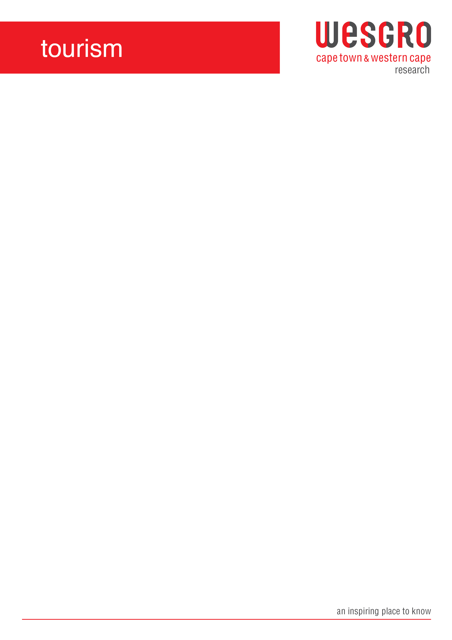

Contents

1.1 Overview of international trends and patterns in Swellendam 2

1.2 Top international markets 2

1.2 Age group of respondents 2

1.3 Overnight visitor trends and average length of stay 3

1.4 Accommodation usage and spend 3

1.5 Travel group size 4

1.6 Main purpose of visit 5

1.7 Main activities 5

1.8 Information Sources 5

1.9 Main mode of transport 6

1.10 Average daily Spend 6

2. Key trends of international holiday/leisure travellers to Swellendam 7

3. Key trends of international overnight and day visitors to Swellendam 8

4. Trends and patterns of international markets to Swellendam 9

5. Acknowledgements 9

# 1.1 Overview of international trends and patterns in Swellendam

|  |  |
| --- | --- |
| **OVERVIEW OF INTERNATIONAL VISITOR TRENDS AND PATTERNS IN SWELLENDAM, 2014/2015** | |
| **TOURISM INDICATOR** | **SWELLENDAM** |
| % Share overnight visitors | 56.3% |
| % Share day visitors | 43.8% |
| Top domestic  markets | Germany (26.8%) |
| United Kingdom (25.7%) |
| Netherlands (14.3%) |
| Main purpose of visit | Holiday/leisure (98.3%) |
| Honeymoon/weddings & VFR (0.6% each) |
|
| Most common travel  group size | Pairs (69.5%) |
| Fours (10.5%) |
| Most common  length of stay | 1 night (46.9%) |
| 2 nights (36.6%) |
| Most common mode of transport | Rented car (89.6%) |
| Tour bus (4.9%) |
| Top information  sources | Internet/websites (32.3%) |
| Word of mouth (18.2%) |
| Average daily spend | R501-R1000 (41.1%) |
| Type of  accommodation | B&B (34.8%) |
| Guesthouse (32.3%) |
| Average spend on  accommodation | R501-R1000 (40.8%) |
| Top three activities  undertaken | Scenic drives (24.3%) |
| Gourmet restaurants (21.3%) |
| Culture &Heritage (16.3%) |



* 1. **Top international markets**

The top three international markets to Swellendam were predominantly European markets, which were United Kingdom (25.3%), Germany (23.8%) and Netherlands (18.2%).

* 1. **Age group of respondents**

Swellendam is visited by middle age group between 36-50 years (19.3%) and slightly older group between 51-70 years (51.5%) primarily.

|  |  |
| --- | --- |
| **AGE GROUP OF INTERNATIONL VISITORS TO SWELLENDAM** | |
| **AGE GROUP** | **ALL** |
| 21-35 years | 15.8% |
| 36-50 years | 19.3% |
| 51-70 years | 51.5% |
| >70 years | 11.1% |

* 1. **Overnight visitor trends and average length of stay**

The majority of visitors to Swellendam were day visitors 57.8%, which could be visitors to the town for events and festivals and overnight visitors 42.2%, which could be domestic visitors visiting friends and relatives staying overnight.

International visitors to Swellendam enjoy staying mostly for one night (46.9%), two nights (36.7%) and three nights (10.3%), which could be weekend breakaways.

* 1. **Accommodation usage and spend**

B&Bs (35.3%), guesthouse (32.8%) and self-catering (12.3%) was the main type of accommodation that international visitors used when visiting Swellendam.

R501-R1000 (40.2%) and R201-R500/ R1001-R2000 (22.5% each) was main average spend by international visitors to Swellendam making positive impact on accommodation sector of the town.

* 1. **Travel group size**

International visitors to Swellendam enjoyed travelling mostly in pairs (69.5%) preferable as couples on holiday and fours (10.5%), which could preferably be families.

* 1. **Main purpose of visit**

Holiday/leisure (97.6%), honeymoon/weddings (0.8%) and VFR (0.8%) was the main purpose of visit for International visitors to Swellendam.

* 1. **Main activities**

The top three main activities for international visitors to Swellendam were scenic drives (25.7%), gourmet restaurants/cuisine (25.0%) and culture/heritage (18.6%).

* 1. **Information Sources**

Internet/websites (35.0%) and word of mouth (17.1%) was the main source of information used by international visitors to gather information on the town before travelling there, books/magazines (9.4%) and VICs (9.0%) was also very popular source of information amongst international visitors to the town.

* 1. **Main mode of transport**

International visitors to the town preferred to use rented cars (92.4%), own motor vehicles (3.4%) and tour bus (1.6%) as their main mode of transport.

# Average daily Spend

R201-R500 (35.0%) and R501-R1000 (42.5%) was main average spend by international visitors to Swellendam making positive impact on the local economy of the town.

|  |  |
| --- | --- |
| **KEY TRENDS AND PATTERNS BY HOLIDAY/LEISURE INTERNATIONAL VISITORS, 2014/2015** | |
| **Visitor Profile** | **Holiday/Leisure Traveler** |
| Top international markets | Germany (74.9%) |
| United Kingdom (12.8%) |
| Netherlands (3.7%) |
| Most common age group | 36-50 (25.5%) |
| 51-70 (48.1%) |
| Most common travel group size | Pairs (69.4%) |
| Fours (10.6%) |
| Most common length of stay per town | 2 nights (36.8%) |
| 1 night (47.1%) |
| 3 nights (10.3%) |
| Most common mode of transport | Rented car (89.7%) |
| Tour bus (4.9%) |
| Top information sources | Internet/websites (32.4%) |
| Word of mouth (17.8%) |
| Return Visit (20.5%) |
| Most common type of accommodation | Self-catering (12.1%) |
| B&B (35.1%) |
| Guesthouse (32.0%) |
| Average spend on accommodation | R501-R1000 (40.8%) |
| R201-R500 (22.8%) |
| Average daily spend | R501-R1000 (41.3%) |
| R201-R500 (37.5%) |
| Top five activities | Scenic drives (24.5%) |
| Gourmet restaurants (21.6%) |
| Culture/heritage (16.5%) |
| Outdoor activities (11.4%) |
| Shopping (4.8%) |

# 2. Key trends of international holiday/leisure travellers to Swellendam

# 3. Key trends of international overnight and day visitors to Swellendam

|  |  |  |
| --- | --- | --- |
| **KEY TRENDS AND PATTERNS BY VISITOR TYPE TO SWELLENDAM, 2014/2015** | | |
| **Visitor Profile** | **Overnight Visitor** | **Day Visitor** |
| Top international markets | United Kingdom (25.3%) | United Kingdom (26.1%) |
| Germany (23.8%) | Germany (30.6%) |
| Netherlands (18.2%) | Netherlands (9.4%) |
| Main purpose of visit | Holiday/leisure (97.6%) | Holiday/leisure (99.2%) |
| Most common travel group size | Pairs (76.0%) | Pairs (61.2%) |
| Fours (9.3%) | Five & More (12.7%) |
| Most common age group | 36-50 (19.3%) | 36-50 (40.7%) |
| 51-70 (51.5%) | 51-70 (39.5%) |
| Most common mode of transport | Rented Car (92.4%) | Rented Car (86.0%) |
| Own motor vehicle (3.4%) | Tour bus (9.1%) |
| Top information sources | Internet/websites (35.0%) | Internet/websites (28.8%) |
| Word of mouth (17.1%) | Word of mouth (19.5%) |
| Most common type of accommodation | B&B (35.3%) | - |
| Guesthouse (32.8%) | - |
| Average spend on accommodation | R501-R1000 (40.2%) | R501-R1000 (53.1%) |
| Average daily budget | R501-R1000 (42.5%) | R201-R500 (41.9%) |
| Top five activities | Scenic drives (23.3%) | Scenic drives (26.4%) |
| Gourmet restaurants (18.2%) | Scenic drives (25.7%) |
| Culture/heritage (14.7%) | Gourmet restaurants (25.5%) |
| Outdoor activities (14.0%) | Culture/heritage (18.6%) |
| Shopping (5.3%) | Outdoor activities (8.0%) |

*Note: Blank cells indicate that the sample was not big enough for a valid statistical interpretation.*

# 4. Trends and patterns of international markets to Swellendam

|  |  |  |  |
| --- | --- | --- | --- |
| **OVERVIEW OF TRENDS AND PATTERNS BY TOP INTERNATIONAL MARKETS TO SWELLENDAM, 2014/2015** | | | |
| **TOURISM INDICATOR** | **United Kingdom** | **Germany** | **Netherlands** |
| Main purpose of visit | Holiday/leisure (97.9%) | Holiday/leisure (98.0%) | Holiday/leisure (98.3%) |
| Most common travel group size | Pairs (75.6%) | Pairs (69.9%) | Pairs (69.7%) |
| Fours (8.4%) | Fours (9.8%) | Fours (14.1%) |
| Most common length of stay | 1 night (38.5%) | 1 night (43.8%) | 1 night (51.2%) |
| 2 nights (40.2%) | 2 nights (42.0%) | 2 nights (36.0%) |
| Most common mode of transport | Rented car (91.5%) | Rented car (89.6%) | Rented car (80.8%) |
| Tour bus (5.6%) | Tour bus (7.2%) | - |
| Top information sources | Word of mouth (21.2%) | Word of mouth (15.9%) | Internet/websites (37.3%) |
| Internet/websites (31.9%) | Internet/websites (37.3%) | Word of mouth (13.9%) |
| Most common type of accommodation | Guesthouse (42.4%) | Guesthouse (29.2%) | B&B (34.7%) |
| B&B (28.6%) | B&B (37.3%) | Guesthouse (33.3%) |
| Average daily spend on accommodation | R501-R1000 (44.3%) | R501-R1000 (35.8%) | R501-R1000 (35.2%) |
| Average daily spend | R501-R1000 (45.5%) | R201-R500 (42.5%) | R501-R1000 (46.1%) |
| Top three activities undertaken | Scenic Drives (25.5%) | Scenic drives (21.1%) | Scenic drives (21.1%) |
| Culture & Heritage (15.6%) | Culture & Heritage (12.9%) | Culture & Heritage (12.9%) |
| Wine Tasting (10.6%) | Gourmet restaurants (10.6%) | Gourmet restaurants (10.6%) |

*Note: Blank cells indicate that the sample was not big enough for a valid statistical interpretation*

# 5. Acknowledgements

Acknowledgements and many thanks go to Swellendam Tourism for supplying the data which made this publication possible and whose continued and unwavering support will sustain the forthcoming issues.

*For more information on this publication and other Wesgro publications please contact* [*research@wesgro.co.za*](mailto:research@wesgro.co.za)*. For more publications like this visit the Wesgro publications portal on our website at http://wesgro.co.za/publications*